Mooring Summer Research Report 2022 - South data

By: Lily Bright

**Methods:**

Isolating Relevant Data:

We began recording our data in January of 2017 in the southern part of the La Amistad International Peace Park. We had 36 cameras that were posted in 26 different sites recording data 24 hours a day, 7 days a week. Three trails were the focus; The Kamuk trail, the biological corridor and the Pila trail. Some of the cameras appeared to be duplicates, specifically K1-K9 and Pila01 and Pila01b. After comparing the data from each paired camera, it was determined to collapse these cameras into one. K1-K9 were combined with K01-K09, and Pila01B was combined with Pila01. All of these combined cameras were notated as paired although the data was combined. Next using R programming the data was separated from each record using “unique” and a “loop” code. Initially an independent record was defined as a photo/record with a time difference of 1 hour. After some consideration it was felt 24 hours was a more accurate representation of the data as the focus was general occupancy versus recaptures. Once separated into individual records, R programming was used to build a chart displaying all records over the course of time the cameras were run. The total records for each month and year were recorded and helped to develop a four-month window for each camera. This was determined based on the window for each camera that had enough independent records for analysis. Once a window was chosen, R programming was used to divide the dataset into just those records from the chosen window. First R was to create a table with just the chosen dates. It was then programmed to only show records in our dataset in that time window. This helped us focus the dataset into a smaller more manageable size with our specifics outlined.

Extracting Data:

Our next portion of analysis involved retrieving satellite metadata from various websites, to include one that belonged to NASA. Data from the general area of each dataset was used. The metadata was then downloaded where the data was extracted using the coordinates for each camera trap. This was done to develop a map of the data as well as the location of our cameras. This helped to extract data for covariates later. This was used to then extract data for forest coverage of the area, human footprint impact(HFI), elevation, net primary productivity(NPP), distance to rivers, distance to roads, forest fragmentation, edge density and patch density. Each set of data extracted from these downloadable databases produced covariate data for each site. This data was then added to a table of site covariates.

This was also done for observation covariates for detection. Effort was used for a detection covariate as well as the paired cameras. The idea was with effort, the data was split into 7-day periods. The more days the window included the more likely it was expected to detect the intended species. With the paired cameras, it was expected to see more/higher detection than the single, unpaired cameras.

Running Models:

Once all the metadata was extracted for the covariates, occupancy models for each of the three species, puma, paca and peccary, were created. Each model was run in R programming using only 1’s for detection and occupancy; this was called the null model. Each model after was then compared to the null model. Models were run in R using effort as the alternative for detection covariates, and the others as site, or occupancy, covariates. Using the summary of these models we were able to compare the Akaike information criterion (AIC) of each model to determine that model with the best fit. AIC is a method for determining how well a model fits the data it was created from. The lower this number is, the better the data fits the model. AIC tables were created for each species and the best model was deduced from this.

**Results:**

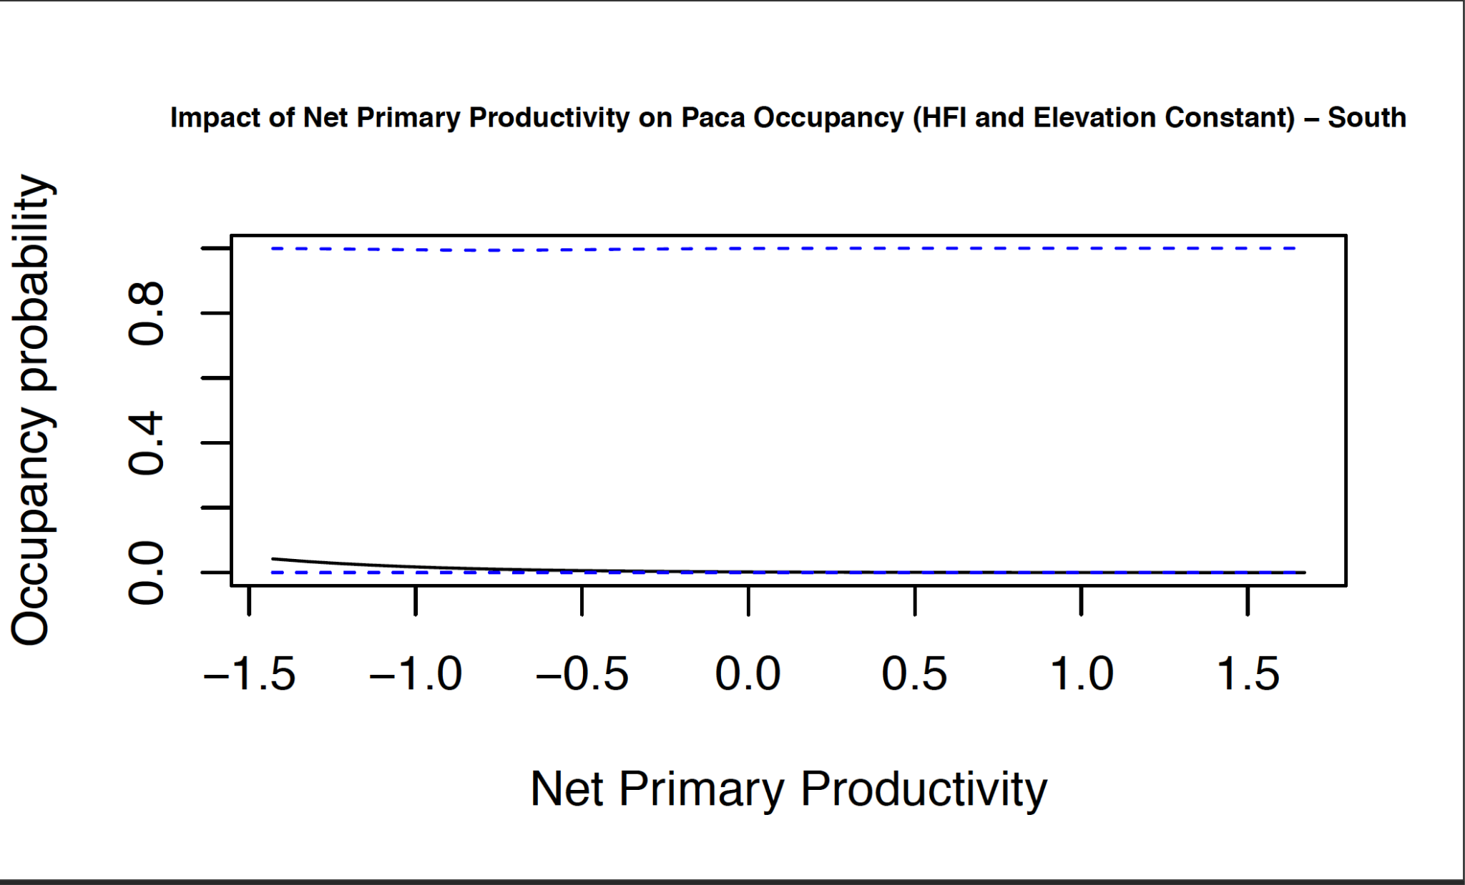

***Figure 1*** *: Correlation between net primary productivity and paca occupancy probability.*

***Figure 2*** *: Correlation between human footprint index and paca occupancy probability.*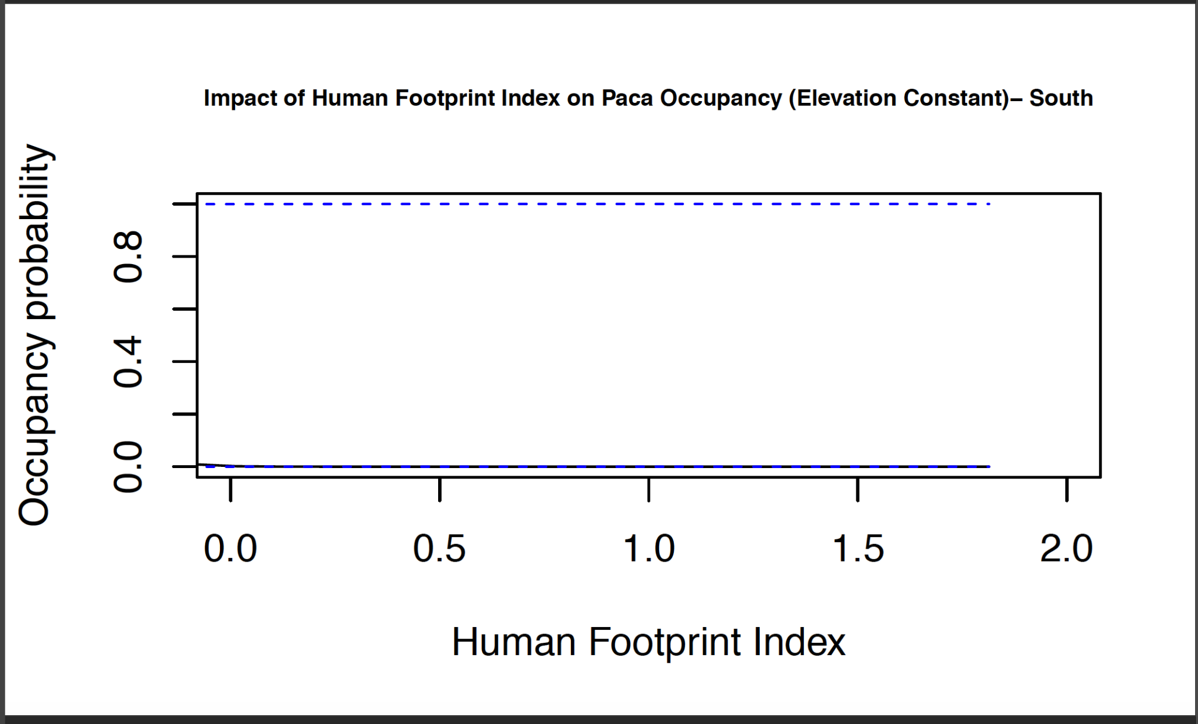

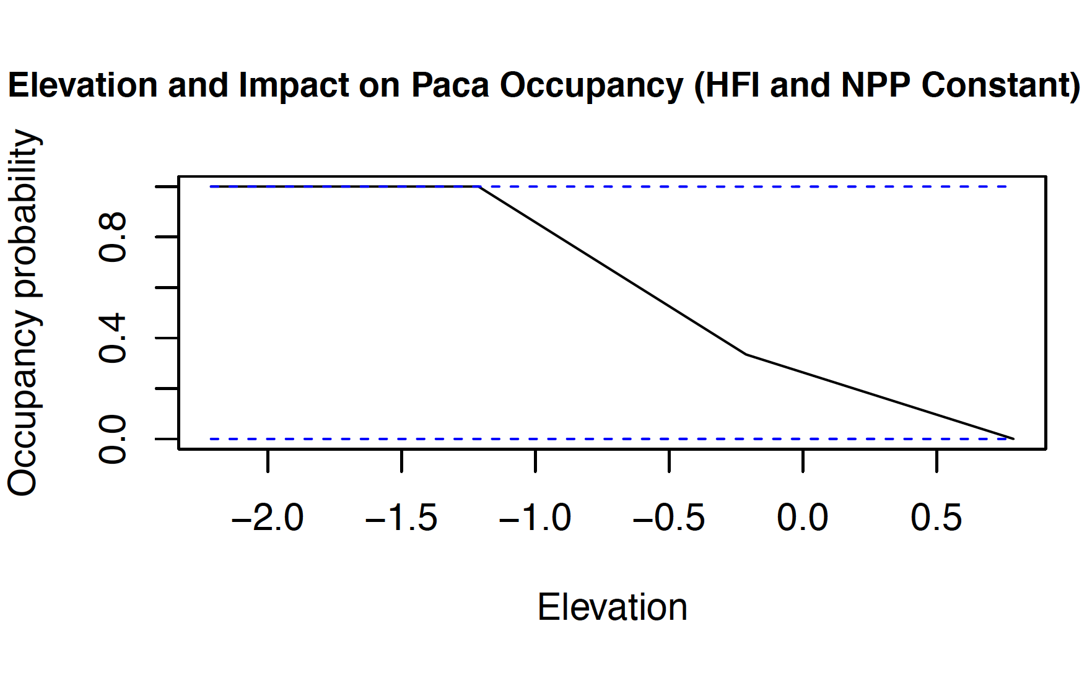

***Figure 3*** *: Correlation between elevation and paca occupancy probability.*

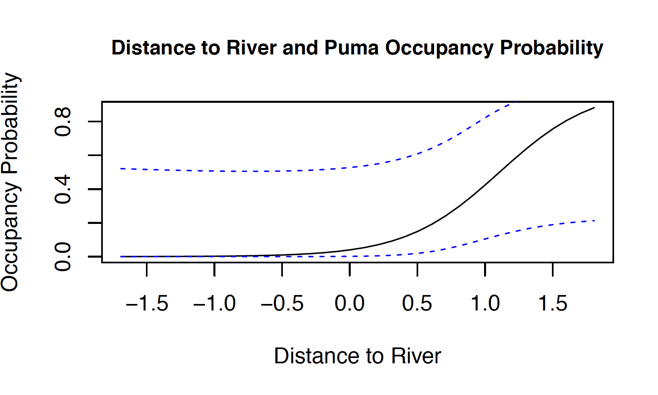

***Figure 4*** *: Correlation between distance to rivers and puma occupancy probability.*

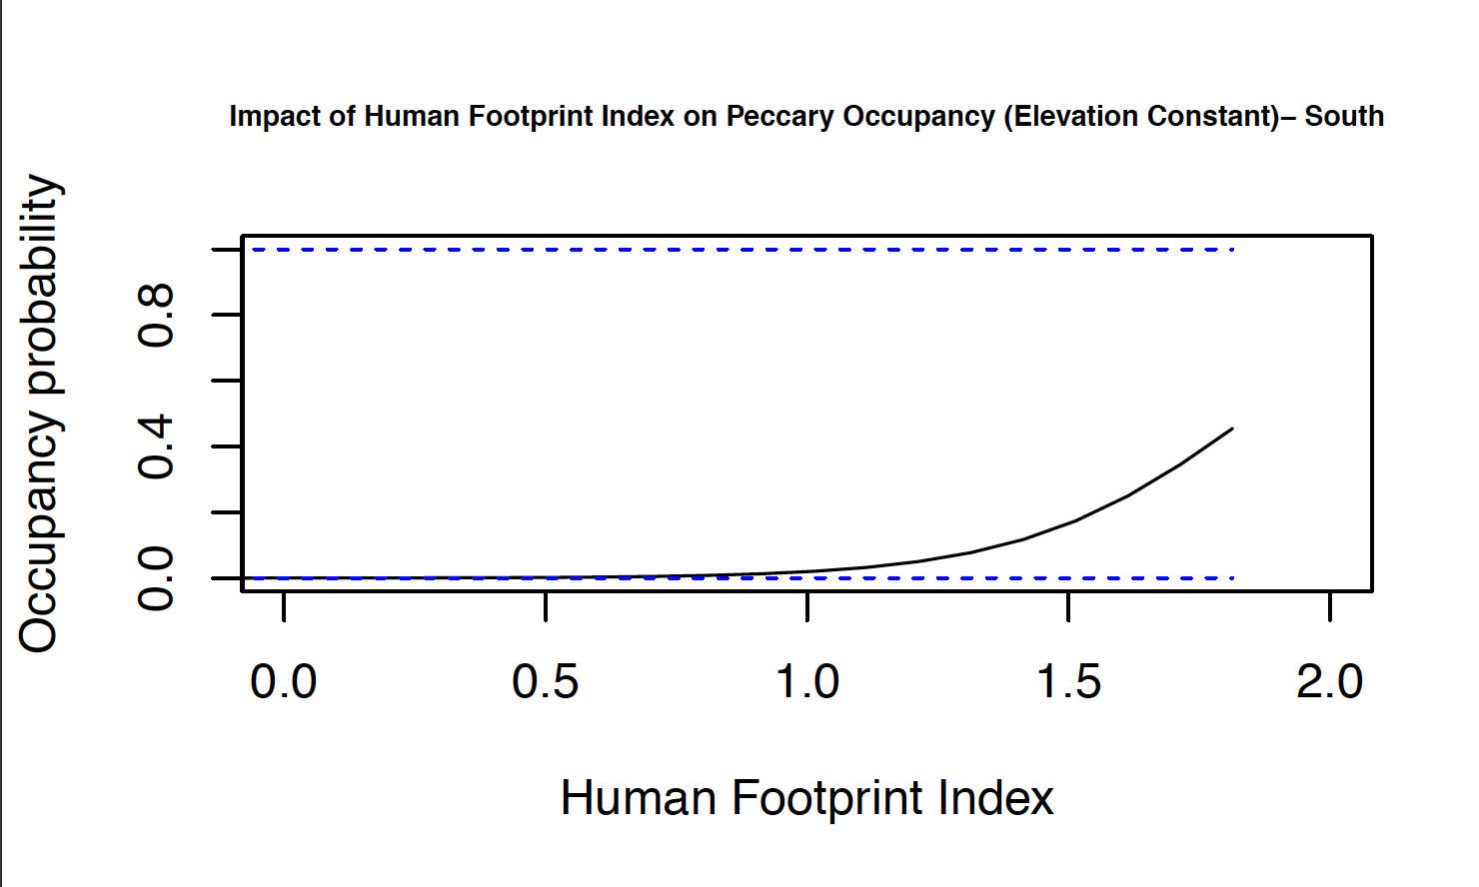

***Figure 5*** *: Correlation between human footprint index and peccary occupancy probability.*

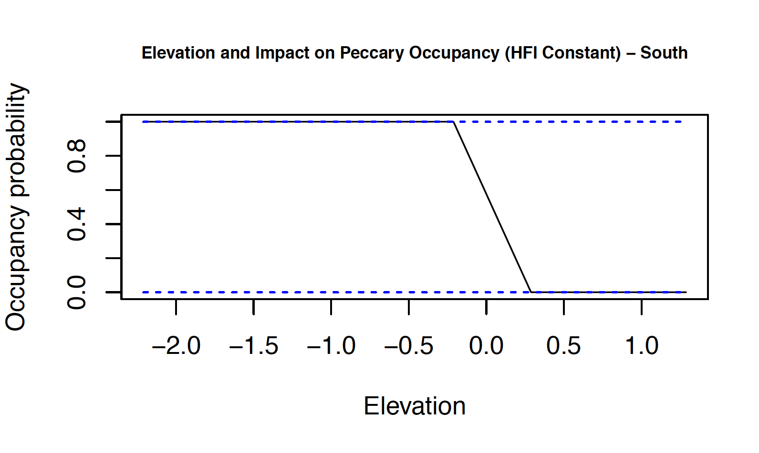

***Figure 6*** *: Correlation between elevation and peccary occupancy probability.*

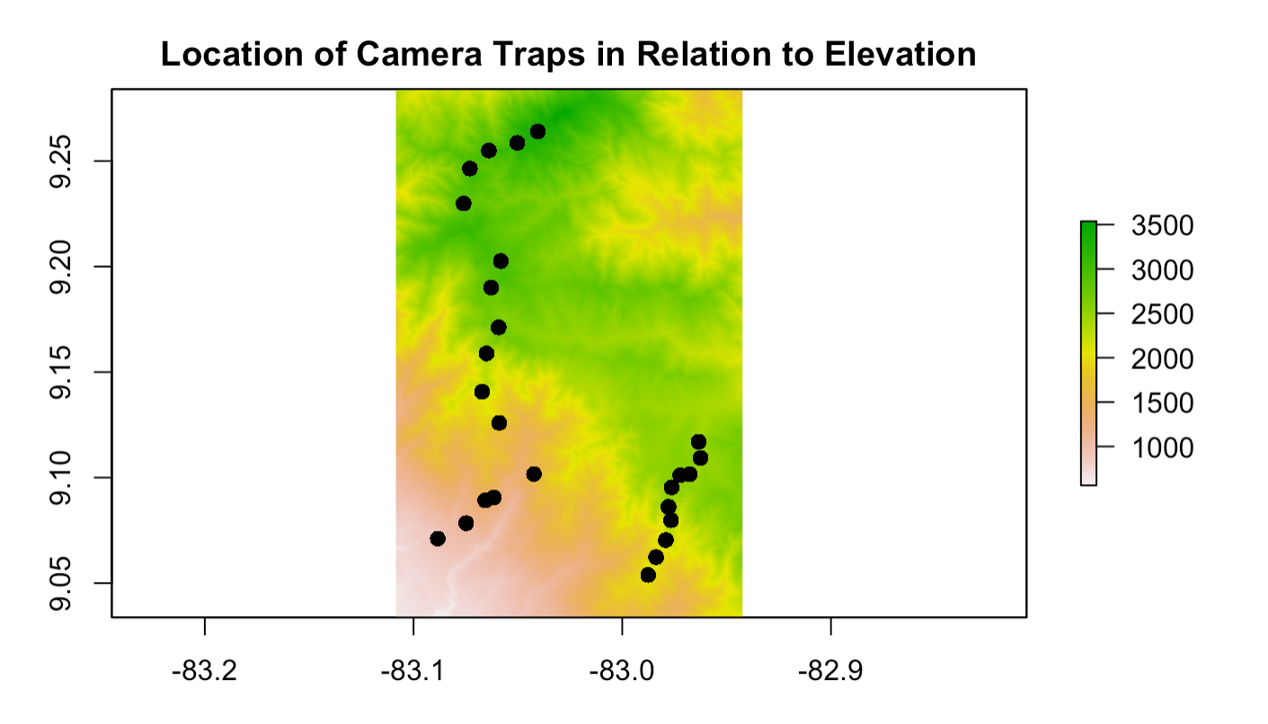

***Figure 7*** *: Map of all 26 camera traps in relation to their latitude and longitude and elevation.*

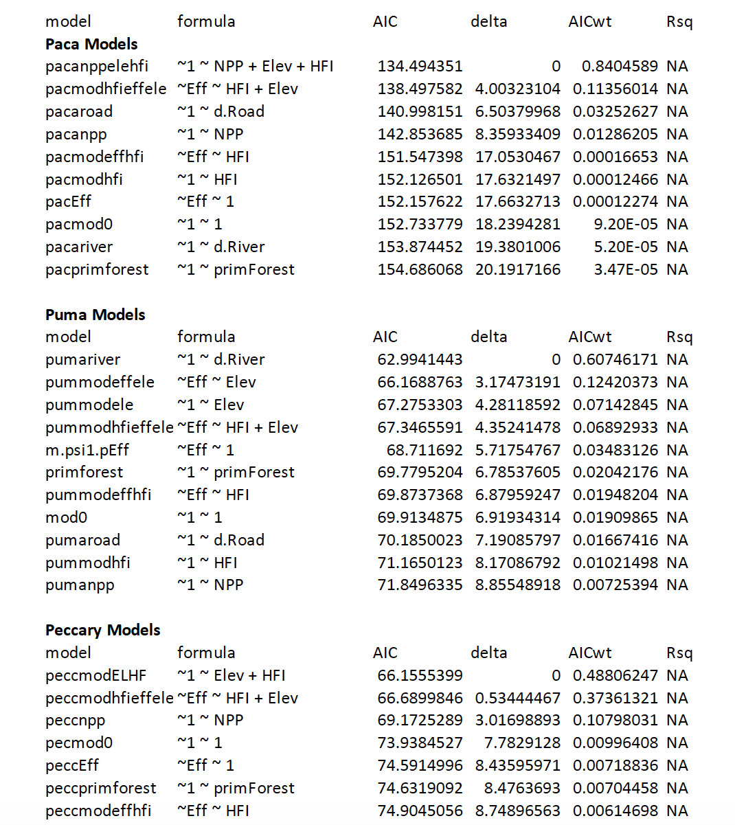

***Table 1*** *: Table displaying each model for species puma, paca and peccary and their perspective AICs.*

When separated into the appropriate time window, the data produced 3548 individual records in the dataset. Within that there were 33 different species represented. A map was then created using the camera trap coordinates and an elevation map downloaded from the NASA website(Figure 7).

Based on our AIC tables (Table 1) we were able to determine relationships between the species and some of our covariates. For pumas, the distance to river model was our best model with elevation as a close second. For peccaries the best model included human footprint index, and elevation. For pacas the best model included net primary productivity, elevation, and human footprint index. However, none of the occupancy models had p-values below .05, indicating there was no significance in the data. Figures 1-3 are plots of paca data in relation to each covariate. Figure 1 shows a nearly flat line with large confidence intervals, implying paca occupancy has little significance to net primary productivity. Figure 2 shows human footprint impact on paca occupancy and again we saw a nearly straight line indicating little significance between paca occupancy and human footprint index. Figure 3 is a plot of Paca occupancy against elevation. Here there was a more interesting plot that appears to suggest paca occupancy was less likely the higher the elevation. Figure 4 shows the relationship between puma occupancy and distance to rivers. This figure is easier to see the relationship between the species and the covariate. It appears that the further from rivers the more likely there will be puma occupancy. Figure 5 and 6 are plots for human footprint index and elevation for peccaries. Like the paca, elevation appears to have a negative relationship with peccary occupancy (Figure 6) and human footprint index appears to have a positive relationship with peccary occupancy (Figure 5).

Despite the fact that none of our models showed significance based on the high p-values, the AICs from these models do imply a relationship between these species and their covariates. For detection models all the species, except peccary, had better models when including effort than the null model.